**AUTOMATIC ROOMLIGHT CONTROLLER WITH BI DIRECTIONAL VISITOR COUNTER**

NITISH M ARIF KM LAKSHMANAN T

B-TECH CSE IOT-A B-TECH CSE IOT-A B-TECH CSE IOT-A

23011102057 23011102036 23011102042

INTRODUCTION:

The "Automatic Room Light Controller with Bi Directional Visitor Counter using Arduino Uno" is a sophisticated system designed to efficiently manage room lighting based on occupancy and count visitors entering and exiting the room. The project employs Arduino Uno microcontroller to automate the control of room lighting and track the number of visitors in both directions. Infrared sensors are utilized to detect the presence of visitors and accurately count their movements. The system is bi-directional, ensuring precise tracking of individuals entering and leaving the room.

Advantages and Limitations Advantages Can be used for automatic room light control.

It will help to save electricity. Whenever no one is there in room the appliances will be off. In School/companies it will help to check if somebody is there in the zone or not. If the data on display unit is zero the security guards can shut the gate easily. Limitations It is used only when one person cuts the rays of the sensor hence cannot be used when two or more persons cross the door simultaneously. When anybody is inside the room and we need to switch off the power then we've to do it manually. So, in this case we fail to automatically control the light.

MOTIVATION:

Energy Efficiency: One of the primary motivations is to promote energy efficiency by automatically controlling room lights based on occupancy. This can lead to significant energy savings, especially in areas where lights are often left on unnecessarily. Convenience: Automatic control eliminates the need for manual switching of lights, providing convenience to occupants and reducing the chances of lights being left on accidentally. Cost Savings: Reduced energy consumption translates to cost savings for homeowners, businesses, and institutions, making it an economically beneficial project in the long run.

Environmental Impact: By promoting energy conservation, the project contributes to reducing the environmental impact associated with excessive energy usage, such as carbon emissions from power generation.

Technology Integration: Implementing a bi-directional visitor counter involves integrating various technologies like sensors, microcontrollers, and communication protocols, providing a practical learning experience in electronics and programming. Safety and Security: Automated lighting control can enhance safety and security by ensuring that rooms are well-lit when occupied, deterring potential intruders or hazards.

Data Collection and Analysis: The visitor counter component allows for data collection on room occupancy patterns, which can be analyzed to optimize energy usage further or improve space utilization in commercial settings.

Customization and Scalability: The project can be customized and scaled according to specific requirements, making it adaptable for different types of spaces, from homes to large buildings.

Innovation and Creativity: Developing such a project fosters innovation and creativity in designing solutions for everyday challenges, encouraging exploration of new ideas and technologies.

Educational and Research Purposes: For students and researchers, this project serves as a practical application of concepts in electronics, embedded systems, and automation, enhancing understanding and skills development in these fields.

LITERARY SURVEY:

Research Papers:

"Design and Implementation of an Automatic Room Light Controller with Visitor Counter" by P. Pradeep Kumar and M. Narasimha Rao. This paper discusses the design and implementation of a system that automatically controls room lights based on occupancy using a visitor counter.

"Bi-Directional Visitor Counter with Automatic Room Light Controller" by D. K. Phatak et al. This paper explores a system that integrates a bi-directional visitor counter with an automatic room light controller to enhance energy efficiency and convenience.

IEEE Publications:

IEEE Xplore Digital Library: Search for papers and articles related to automatic room light controllers, visitor counters, and their integration for energy-saving applications.

IEEE Transactions on Industrial Electronics and IEEE Sensors Journal: These journals often feature research on sensor-based systems and automation, which are relevant to this project.

Books and Guides:

"Arduino Projects for Dummies" by Brock Craft. This book includes projects related to Arduino microcontrollers, which are commonly used in building automated systems like room light controllers and visitor counters.

"Raspberry Pi Cookbook" by Simon Monk. Raspberry Pi is another platform suitable for such projects, and this book offers practical guidance on building various electronic projects.

Online Resources and Tutorials:

Instructables.com: This website hosts numerous tutorials and DIY projects related to automation, including automatic room light controllers and visitor counters.

Arduino and Raspberry Pi official websites: These platforms provide documentation, tutorials, and community forums where you can find project ideas and support.

Academic Institutions and Research Centers:

Check the websites of universities or research centers that specialize in electrical engineering, automation, or embedded systems. They may have published papers or projects related to automatic room light controllers and visitor counters.

PIN DIAGRAM:

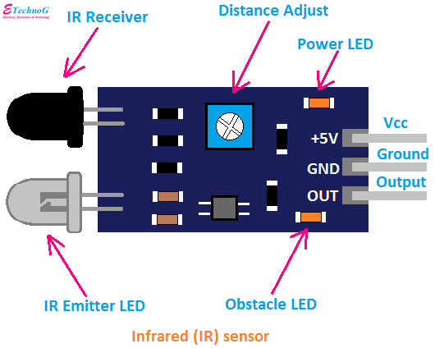

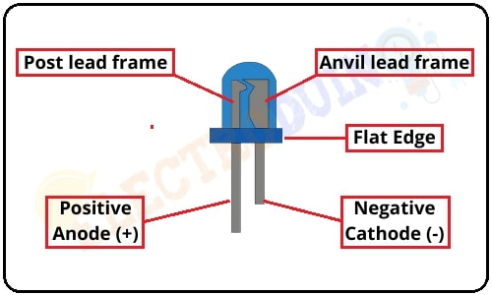

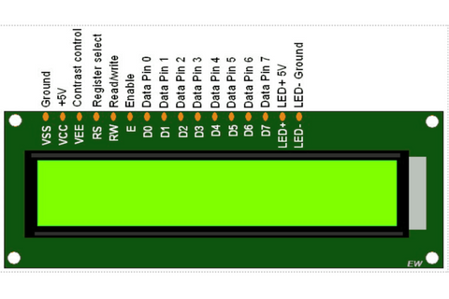

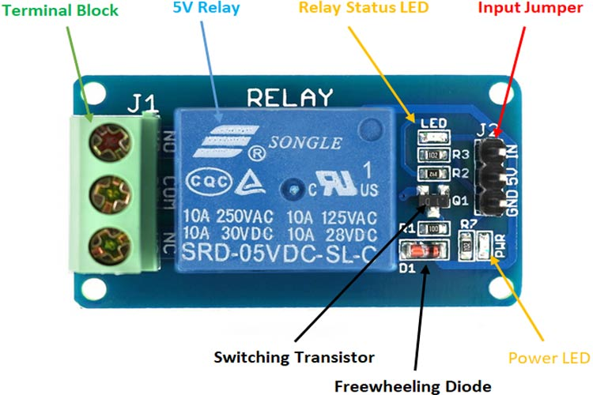

CIRCUIT DIAGRAM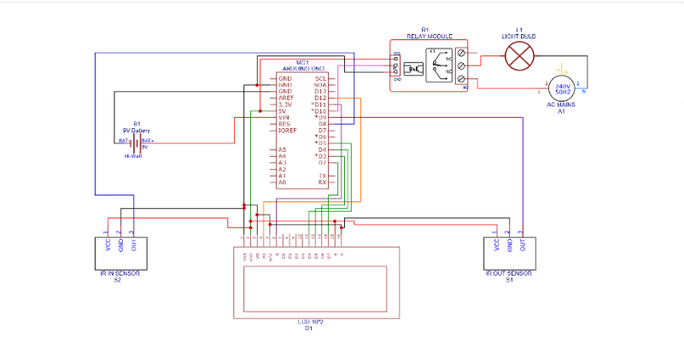

COMPONENT FEATURES:

Arduino Uno Microcontroller:

The Arduino microcontroller is a versatile and widely used open-source hardware and software platform designed for electronics prototyping and do-it-yourself (DIY) projects. It comes in various models, each featuring different specifications such as processor type, clock speed, number of digital and analog pins, operating voltage, and memory capacity. Common models include the Arduino Uno, which features an ATmega328P processor running at 16 MHz, 14 digital pins (including 6 PWM outputs), 6 analog inputs, and 32 KB of flash memory. The microcontroller operates at 5V and can be programmed using the Arduino IDE (Integrated Development Environment), making it accessible to beginners and hobbyists. It supports a range of communication interfaces like USB, UART (Serial), SPI, and I2C, enabling connectivity with sensors, actuators, displays, and other electronic components. The Arduino platform's simplicity, affordability, extensive community support, and compatibility with a wide array of shields and expansion modules have made it a popular choice for projects in robotics, home automation, IoT, educational activities, and rapid prototyping.

IR Sensor:

The Infrared (IR) sensor is a key component in many electronic systems, especially those involving proximity sensing or motion detection. It operates based on the principle of detecting infrared radiation emitted by objects in its field of view. An IR sensor typically consists of an infrared emitter and a receiver, often packaged together in a single module for convenience. When an object comes within the sensor's detection range, it reflects or emits infrared light, which is then received by the sensor. The sensor processes this information to determine the presence or absence of the object. One of the common applications of IR sensors is in automatic systems like motion-activated lights, security alarms, or proximity sensors in electronic devices. For example, in a motion-activated light system, an IR sensor detects movement within its range and triggers the light to turn on, providing illumination only when needed and conserving energy otherwise.

LED:

Light Emitting Diodes (LEDs) are semiconductor devices that emit light when an electric current passes through them. They are widely used in electronics and lighting applications due to their efficiency, durability, and versatility. LEDs come in various colors, sizes, and shapes, making them suitable for a wide range of applications. One of the key advantages of LEDs is their energy efficiency compared to traditional incandescent bulbs. LEDs produce light through a process called electroluminescence, where electrons in the semiconductor material recombine with electron holes, releasing energy in the form of photons (light). This process is much more efficient than the heating of a filament in incandescent bulbs, resulting in significant energy savings.

BREADBOARD:

A breadboard is a crucial tool in electronics prototyping and circuit design, providing a platform for creating temporary circuits without the need for soldering. It consists of a plastic board with rows and columns of interconnected holes, allowing electronic components to be easily inserted and connected to each other. Here's an explanation of how a breadboard works and its typical usage:

The main body of a breadboard is divided into two sections, often referred to as the power rails and the main grid. The power rails run along the sides of the board and are typically labeled with red and blue markings. These rails are used to supply power to the components on the breadboard, with the red rail usually connected to the positive voltage (Vcc) and the blue rail connected to ground (GND).

LCD DISPLAY:

An LCD (Liquid Crystal Display) is a flat panel display technology that uses liquid crystals sandwiched between two layers of glass or plastic to create images or text. LCDs are widely used in electronic devices such as calculators, digital watches, computer monitors, television screens, and various types of information display systems. Here's a description of how an LCD display works and its typical applications:

LCDs work on the principle of manipulating the properties of liquid crystals to control the passage of light through them. Each pixel on an LCD screen consists of liquid crystals that can be manipulated to either block or allow light to pass through. This manipulation is achieved by applying an electric current to the liquid crystals, which changes their orientation and thus alters the amount of light transmitted through each pixel.

SINGLE MODULE RELAY:

A single module relay is a compact electronic device designed to control the switching of electrical circuits. It consists of several key components, including a relay switch, driver transistor, protection diode, and input/output terminals. The relay switch, typically an electromagnetic relay, is the core component responsible for making or breaking electrical connections. When an electric current is applied to the relay coil, it generates a magnetic field that causes the relay contacts to move and switch the connected circuit.

The driver transistor acts as a switch, controlling the current flowing through the relay coil based on the input signal received. This allows for precise control over the relay's operation. Additionally, a protection diode is often included in the circuit to safeguard the driver transistor from voltage spikes that occur when the relay coil is de-energized.

Single module relays feature input terminals for connecting to a control signal source, such as a microcontroller or sensor, and output terminals for connecting to the circuit being controlled, such as lights, motors, or appliances. These relays provide electrical isolation between the control circuit and the load circuit, ensuring the protection of sensitive electronics from high voltages or currents.

METHODOLOGY:

System Overview: Begin by understanding the requirements and objectives of the project. Define the functionality of the automatic room light controller and bi-directional visitor counter. Determine the sensors, microcontroller, and other components needed for the system.

Component Selection: Microcontroller: Choose a suitable microcontroller board such as Arduino Uno or Raspberry Pi.

IR Sensors: Select bi-directional infrared sensors to detect incoming and outgoing visitors.

Relay Module: Choose a relay module to control the room lights based on occupancy.

LCD Display: Optionally, include an LCD display for real-time feedback and status display.

Circuit Design: Create a circuit diagram that includes the microcontroller, IR sensors, relay module, LCD display (if used), and necessary resistors, capacitors, and connectors. Connect the IR sensors to digital input pins of the microcontroller to detect visitor movements. Connect the relay module to a digital output pin of the microcontroller to control the room lights.

Programming: Write the code for the microcontroller using the Arduino IDE or other suitable programming environment. Implement the logic for counting incoming and outgoing visitors based on sensor inputs. Control the relay module to turn the room lights on or off depending on the occupancy status. Optionally, include features such as timeout delays, manual override, or status display on the LCD.

Testing and Calibration: Upload the code to the microcontroller and test the functionality of the system. Calibrate the IR sensors to ensure accurate detection of visitors and minimize false triggers. Test the relay module to verify that it correctly controls the room lights based on occupancy. Integration and Deployment: Assemble the components onto a breadboard or a custom PCB for a more permanent setup. Install the IR sensors at appropriate locations to cover the entry and exit points of the room. Connect the relay module to the room lights and power source. Deploy the system in the target room or area, ensuring proper positioning and alignment of sensors. Validation and Optimization: Validate the system's performance under various conditions, such as different visitor traffic patterns. Optimize the code and system parameters for improved accuracy, reliability, and energy efficiency. Gather feedback from users and make any necessary adjustments or enhancements to the system.

PROGRAM CODE:

#include <LiquidCrystal.h>

LiquidCrystal lcd(12, 11, 5, 4, 3, 2);

#define in 8

#define out 9

#define bulb 10

int count = 0;

int inState = HIGH; // Store the previous state of the in sensor

int outState = HIGH; // Store the previous state of the out sensor

void setup() {

lcd.begin(16, 2);

lcd.print("Visitor Counter");

delay(2000);

pinMode(in, INPUT);

pinMode(out, INPUT);

pinMode(bulb, OUTPUT);

lcd.clear();

lcd.print("Person In Room:");

lcd.setCursor(0, 1);

lcd.print(count);

}

void loop() {

int inValue = digitalRead(in);

int outValue = digitalRead(out);

if (inValue != inState) {

if (inValue == LOW) {

count++;

updateDisplay();

delay(1000); // Delay to stabilize the count

}

inState = inValue;

}

if (outValue != outState) {

if (outValue == LOW && count > 0) {

count--;

updateDisplay();

delay(1000); // Delay to stabilize the count

}

outState = outValue;

}

controlBulb();

}

void updateDisplay() {

lcd.clear();

lcd.print("Person In Room:");

lcd.setCursor(0, 1);

lcd.print(count);

}

void controlBulb() {

if (count == 0) {

digitalWrite(bulb, LOW);

lcd.clear();

lcd.print("Nobody In Room");

lcd.setCursor(0, 1);

lcd.print("Light is Off");

} else {

digitalWrite(bulb, HIGH);

}

}

RESULT:

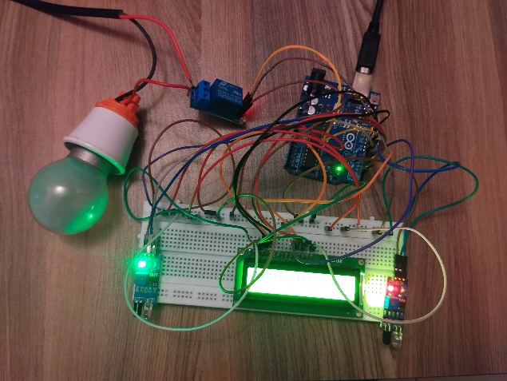

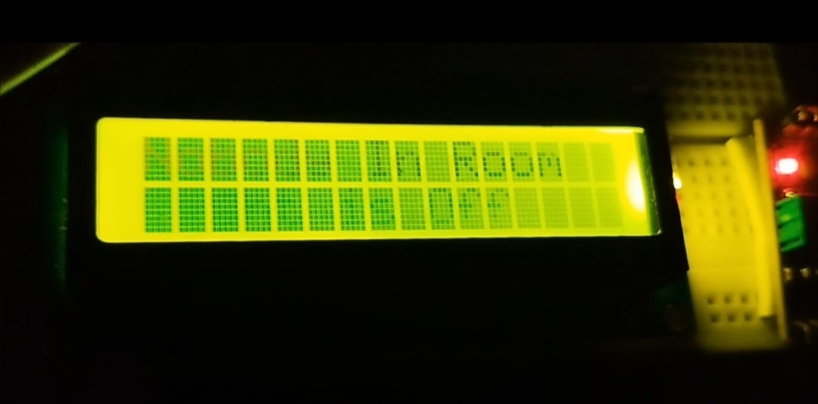

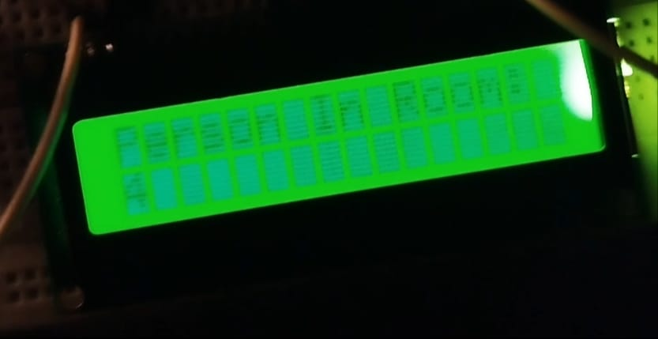

APPLICATION:

It can be used in various rooms like seminar halls, where the capacity of the room is limited and should not be exceeded. It can be used in our homes because we often forget to switch off our room lights It helps in energy conservation Voice alarm system can be used to indicate that room is full & person can't enter inside

Home Automation: In residential settings, the system can be used to automate the control of room lights based on occupancy. It ensures that lights are turned on when someone enters the room and automatically switches them off when the room is vacant, leading to energy savings and convenience for homeowners. Commercial Buildings: In offices, conference rooms, and other commercial spaces, the system can help optimize energy usage by controlling lighting based on occupancy. It ensures that lights are only active in occupied areas, reducing electricity costs and contributing to sustainability efforts.

Retail Stores: Retail establishments can use the system to monitor foot traffic and analyze customer behavior. The visitor counter provides valuable data on customer flow, helping store owners make informed decisions about store layout, product placement, and staffing.

Public Facilities: In public facilities such as libraries, museums, and event venues, the system can manage lighting according to visitor presence. It ensures that lights are on in areas where visitors are present and conserves energy in unoccupied spaces.

Hospitality Industry: Hotels, resorts, and guesthouses can benefit from the system by providing automated lighting control in guest rooms and common areas. It enhances guest experience by offering convenient and energy-efficient lighting solutions. Education Sector: Schools, colleges, and universities can use the system to monitor classroom occupancy and manage lighting accordingly. It helps in optimizing energy usage and creating a more conducive learning environment.

Healthcare Facilities: Hospitals and clinics can implement the system to track patient and staff movement in different areas. It can be integrated with other systems for improved facility management and patient care. Industrial Settings: In manufacturing facilities and warehouses, the system can be used to monitor personnel movement and control lighting in work areas. It enhances safety, reduces energy waste, and improves operational efficiency.

INFERENCE:

Energy Efficiency: The system promotes energy conservation by automatically controlling room lights based on occupancy. Lights are only activated when visitors are detected, reducing unnecessary energy consumption during vacant periods.

Cost Savings: By optimizing lighting usage, the system contributes to cost savings on electricity bills, particularly in commercial and public facilities with high foot traffic.

Convenience: Users benefit from the convenience of automatic lighting control, eliminating the need for manual switching and ensuring that lights are always appropriately adjusted based on room occupancy.

Data Collection: The bi-directional visitor counter component provides valuable data on visitor traffic patterns, which can be analyzed to gain insights into space utilization, peak hours, and visitor behavior.

Improved Security: Automated lighting control enhances safety and security by ensuring that areas are well-lit when occupied, deterring potential intruders or hazards.

Enhanced User Experience: In environments such as retail stores, hotels, and educational institutions, the system enhances the overall user experience by providing a comfortable and well-lit environment while conserving energy.

Scalability: The system can be scaled and customized to suit different environments and requirements, making it adaptable for various applications and settings.

Integration: It can be integrated with other smart building systems and IoT devices for enhanced automation and management of building resources.

CONCLUSION:

Our project offers a practical solution for efficient energy usage and accurate occupancy tracking in indoor spaces. By combining Arduino Uno with infrared sensors, we've created an Automatic Room Light Controller with Bi-Directional Visitor Counter. This system ensures lights are activated based on occupancy and accurately counts visitors entering and exiting the room. It provides a foundation for smarter and more sustainable indoor environments.

REFERENCES:

Khan, M. I. (2017). Design and Implementation of Automatic Room Light Controller with Visitor Counter. International Journal of Engineering Research & Technology (IJERT), 6(12), 492-496.

Kumar, S., & Rana, R. S. (2016).Design and Implementation of Automatic Room Light Controller with Bidirectional Visitor Counter. International Journal of Advanced Research in Electrical, Electronics and Instrumentation Engineering, 5(7), 6405-6411.

Gupta, A., Chaudhary, A., & Jain, P. (2018). Automatic Room Light Controller with Bi-directional Visitor Counter Using Arduino. International Journal of Engineering and Innovative Technology (IJEIT), 7(4), 85-90.

Mohapatra, S., & Mishra, S. K. (2019). IoT-Based Automatic Room Light Controller with Bi-Directional Visitor Counter. International Journal of Recent Technology and Engineering (IJRTE), 8(1), 654-660.

Patel, K., & Prajapati, A. (2017). Design and Implementation of Automatic Room Light Controller with Bi-directional Visitor Counter. International Journal of Scientific Research in Science and Technology (IJSRST), 3(10), 20-24. Arduino official website and documentation: https://www.arduino.cc/ Raspberry Pi official website and documentation: https://www.raspberrypi.org/ Electronics tutorials and resources for Arduino and sensors: https://www.electronicshub.org/